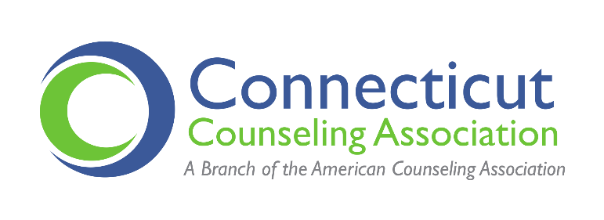
REMOVE LOGO FOR NON-CCA TESTIMONY

Testimony of [NAME], [POSITION], Connecticut Counseling Association/Organization
Public Health Committee Public Hearing, March 22, 2023
RE: SB1228- AN ACT CONCERNING THE STATE'S HEALTH CARE WORKFORCE

Senator Anwar, Representative McCarthy Vahey, Senators Somers, Representative Klarides Ditria and esteemed members of the Public Health Committee, thank you for the opportunity to offer testimony regarding SB1228- An Act Concerning the State’s Health Care Workforce and specifically to advocate for an amendment to include the Counseling Compact as part of the legislation.

My name is [] and I am [POSITION or “a member”] of the Connecticut Counseling Association [and am a licensed professional counselor from --- or provide your professional title and job]. CCA is the only professional organization that represents the Professional Counselors, Professional Counselor Associates, and counseling graduate students here in Connecticut and is a branch of the American Counseling Association.

I am providing testimony urging the committee to include language as part of SB1228 to join the Counseling Compact. By way of background, the Counseling Compact became fully operational in 2022 and now has seventeen states that have joined. Additional, states are also in the process of joining the Compact. Privilege to practice through the Compact will be available to counselors by early 2024 allowing for rapid verification and immediate access to all compact member states. This enhances the workforce, ensures CT remains competitive, meets increasing demand, broadens patient choice, and creates a national database and network for the first time allowing for advancements in behavioral health while optimizing patient safety.

The compact would provide portability of licensure among the Compact states and strike an appropriate balance of increasing access to licensed professional counselors while still maintaining the Connecticut licensure standards and educational requirements. Ultimately, the Compact is the most long-term sustainable solution to the issue of licensure portability, practice across state lines, and workforce shortages in behavioral health.

[SPECIFIC INFORMATION ON WHY IMPORTANT TO YOU]

Thank you for providing me with an opportunity to provide testimony on behalf of the Connecticut Counseling Association and my fellow counselors.

Respectfully,

[NAME, TITLE and CONTACT INFO]

